Hospital Management System

Tables created
Department table:
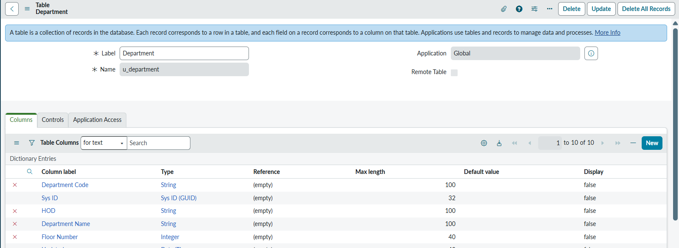
Doctor Table:
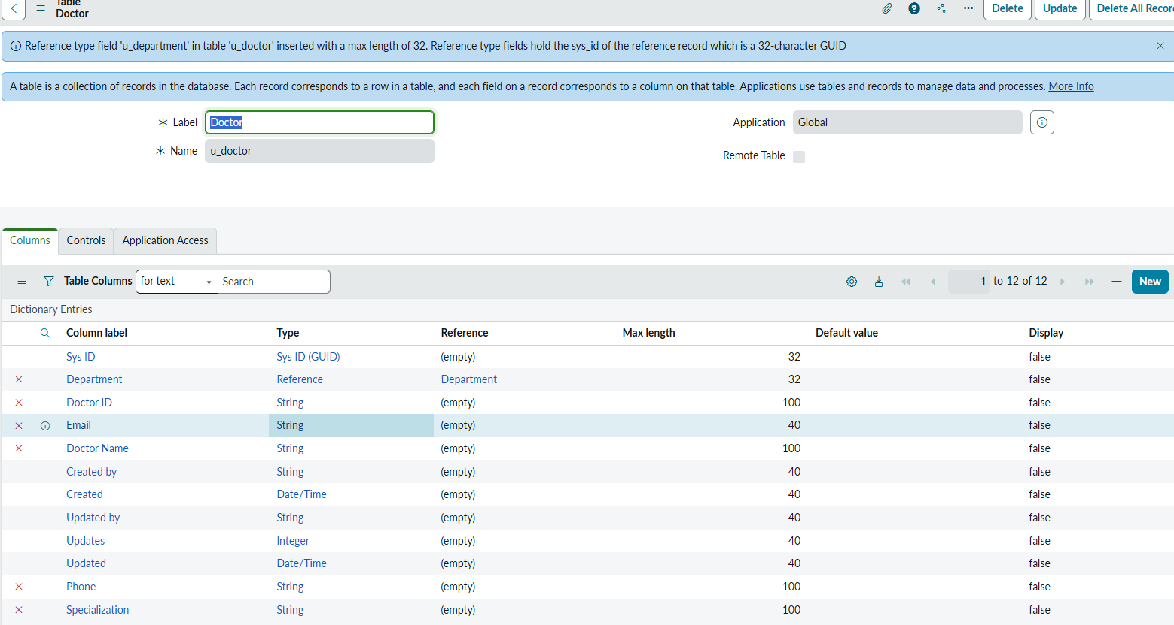
Patient Table:
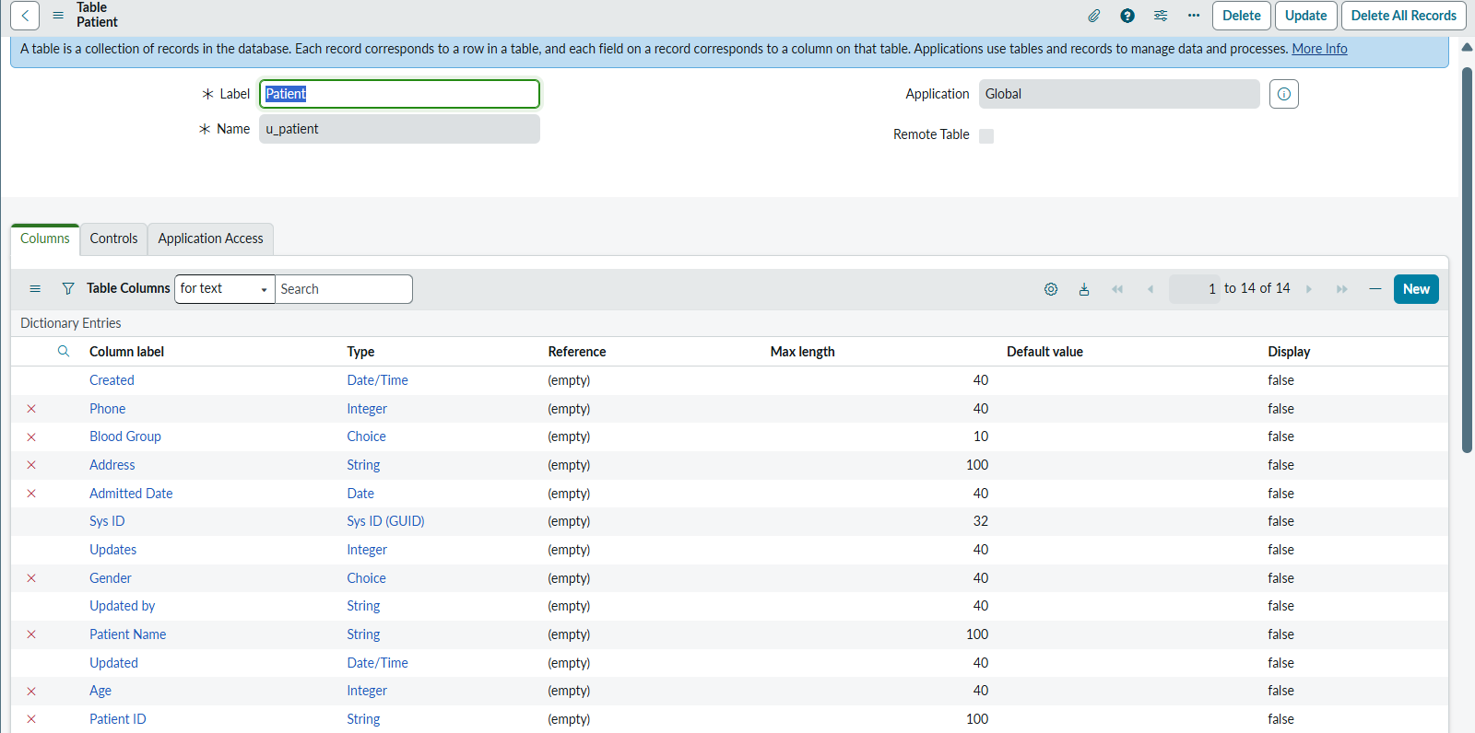
Room Table:
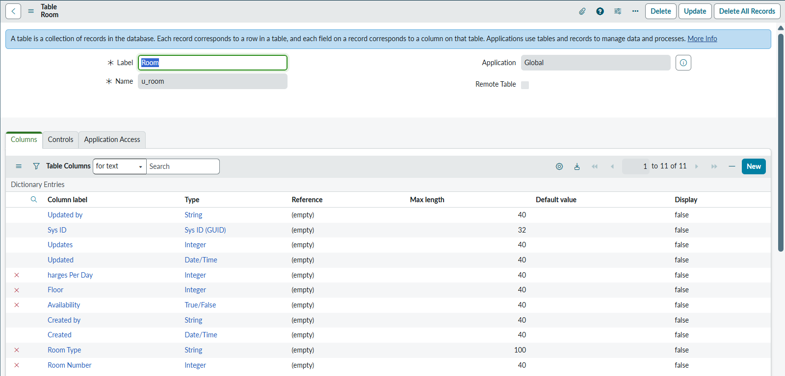

Appointment Table:
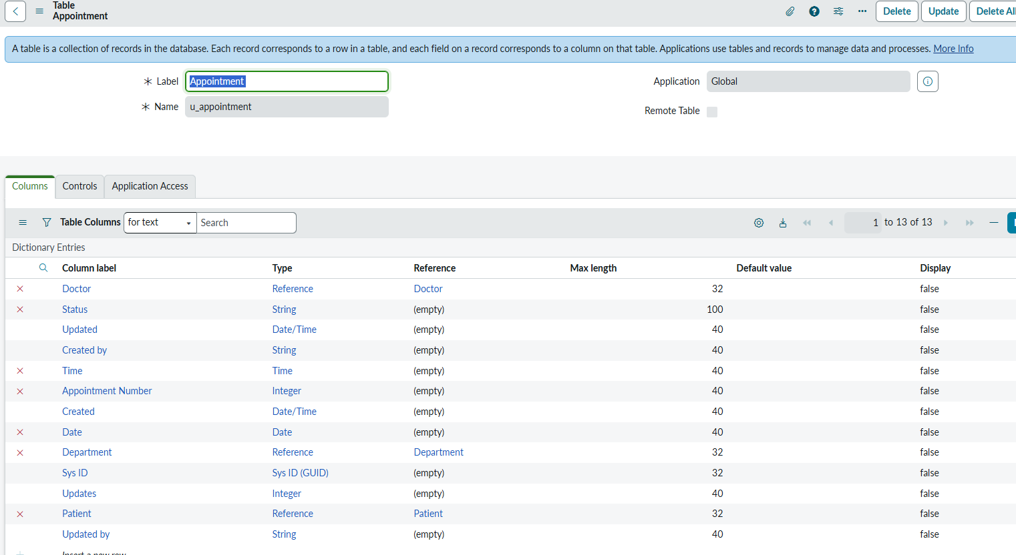
Billing Table:
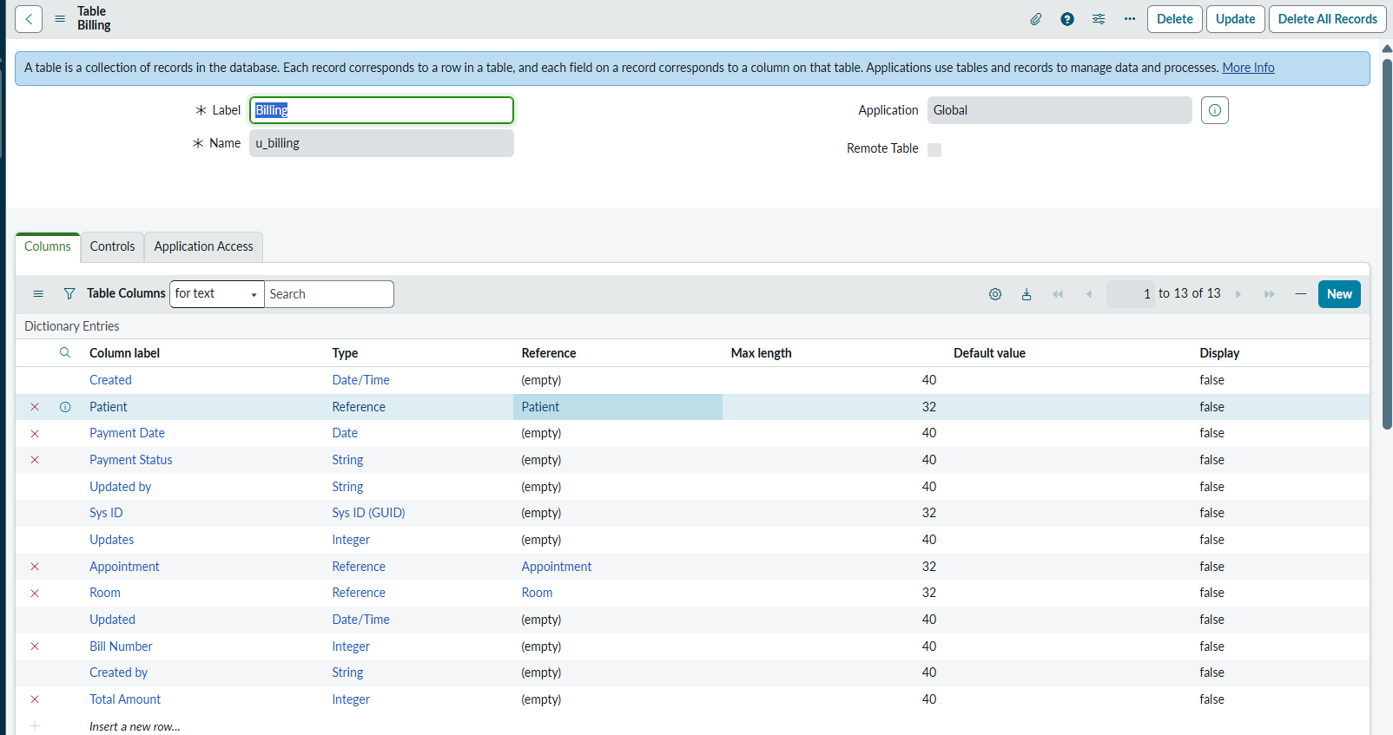

Users, Roles and Groups created
Created users Receptionist, Doctor, Billing Staff, Admin.
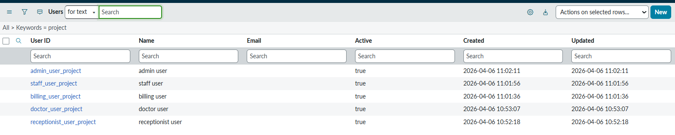
Created roles admin, doctor, receptionist, billing:
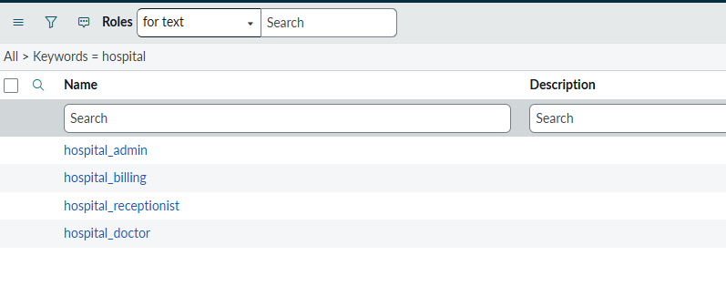
Created groups like Admin Team, Doctors Team, Reception Team, Billing Team
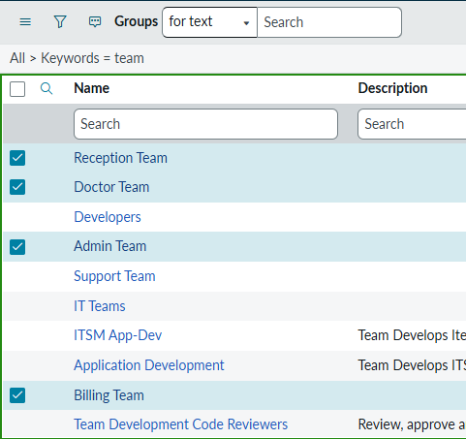

Assigned roles to groups and users
Created users Receptionist, Doctor, Billing Staff, Admin
-Receptionist role added to group:
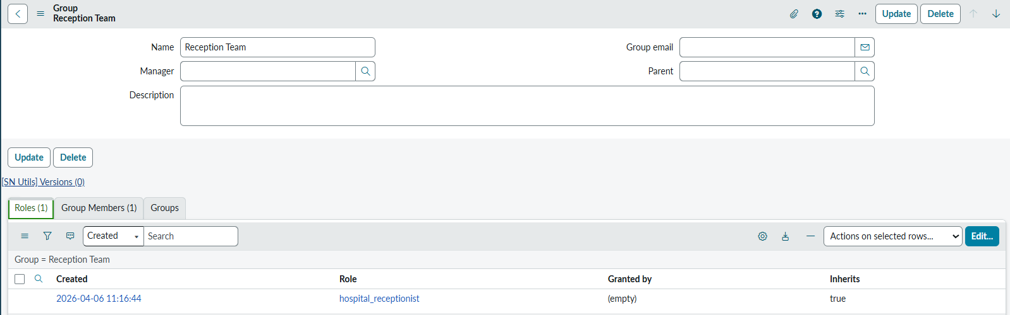
-Receptionist added as a group member:
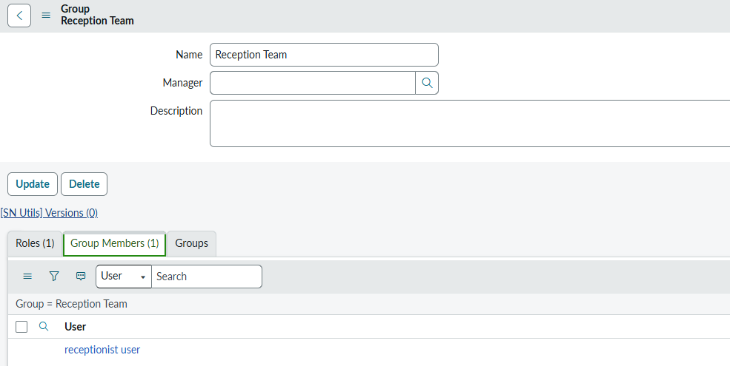
-Doctor role added to group:
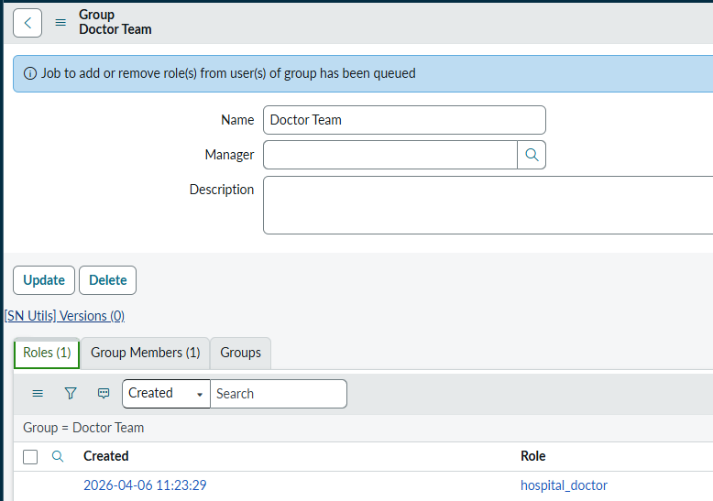

-Doctor added as a group member:
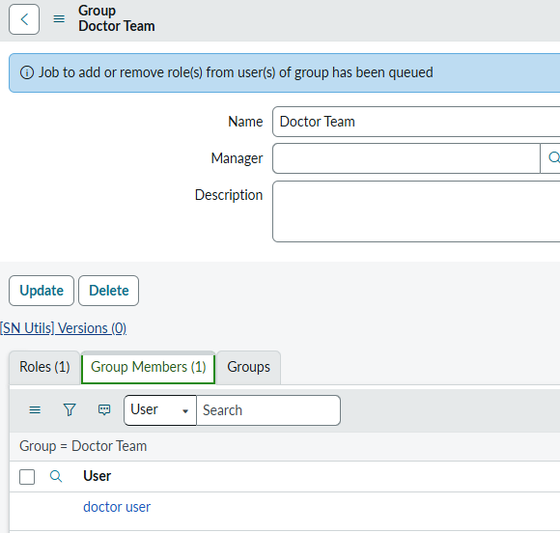

-Billing role added to group:
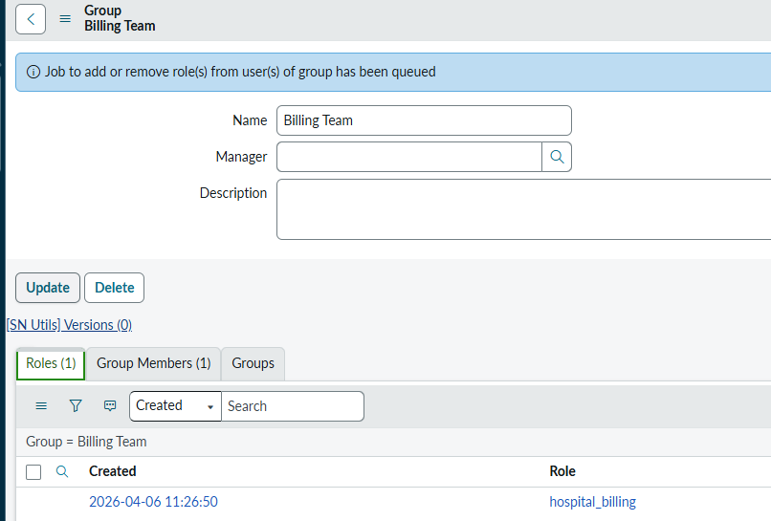
-Billing added as a group member:
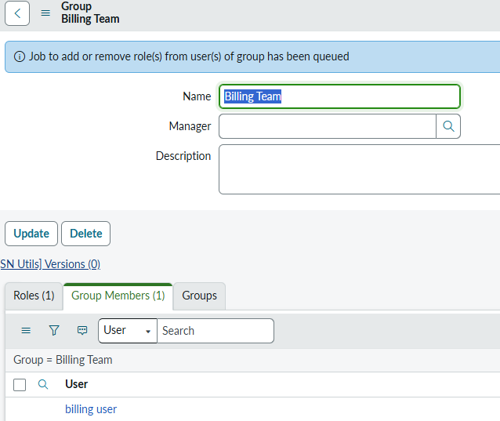
-Billing role added to group:
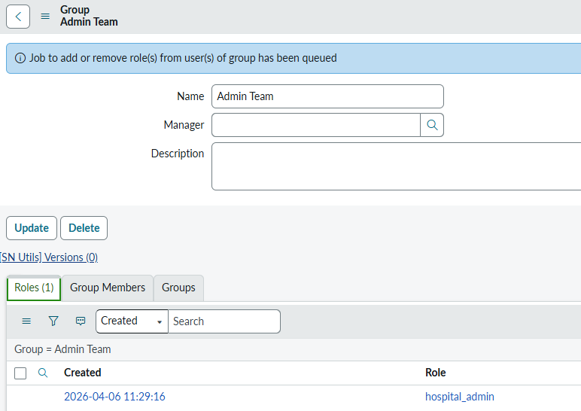
-Billing added as a group member:
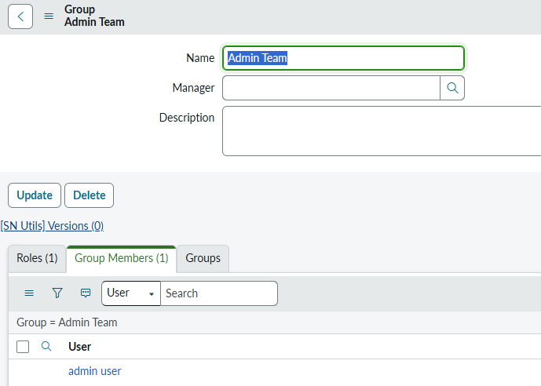

Assigned roles to groups and users
Created users Receptionist, Doctor, Billing Staff, Admin

